FODS ASSIGNMENT 1

Name – Atharva Shivaji Dabkekar
Roll no. – 2090139
PRN - 1251090357
Division – S.Y A
Batch – 2
DATE – 14/07/2026 TIME – 8:00 TO 10:00
QUESTION) Practical 1: Algorithm Design and Complexity Analysis
Design algorithms using pseudocode and flowcharts for real-world problems. Analyse their time and space complexities using Big-O, Theta, and Omega notations.
Write a C/C++/Python program to search a given element in an array using Linear Search. Display the position if found; otherwise display "Element not found". Analyse the algorithm using Big-O, Theta, and Omega notations
ANSWER)
Linear search is simple search technique used to find a element it search one element at a time until the element is found or it reaches the end .
Algorithm:
Step 1] Start
Step 2] Read the size of the array n.
Step 3] Read the array elements.
Step 4] Read the element to be searched (key).
Step 5] Set i = 0.
Step 6] Repeat while i < n
If A[i] == key
Display "Element found at position i + 1"
Stop
Else
Increment i
Step 7]Display "Element not found"
Step 8]Stop

Flowchart:
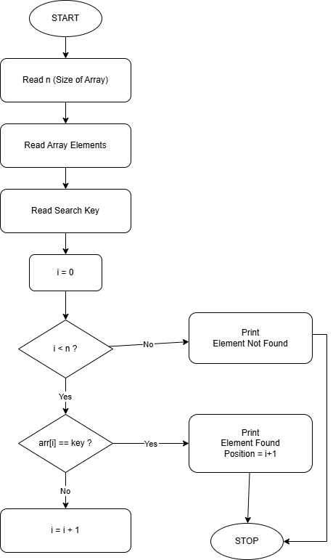
Code:
#include <stdio.h>
int main()
{
int n, i, key;

printf("Enter size of array: ");
scanf("%d", &n);

int arr[n];

printf("Enter array elements:\n");

for(i = 0; i < n; i++)
{
scanf("%d", &arr[i]);
}

printf("Enter element to search: ");
scanf("%d", &key);

for(i = 0; i < n; i++)
{
if(arr[i] == key)
{
printf("Element found at position %d", i + 1);
return 0;
}
}
printf("Element not found");
return 0;
}
Output:
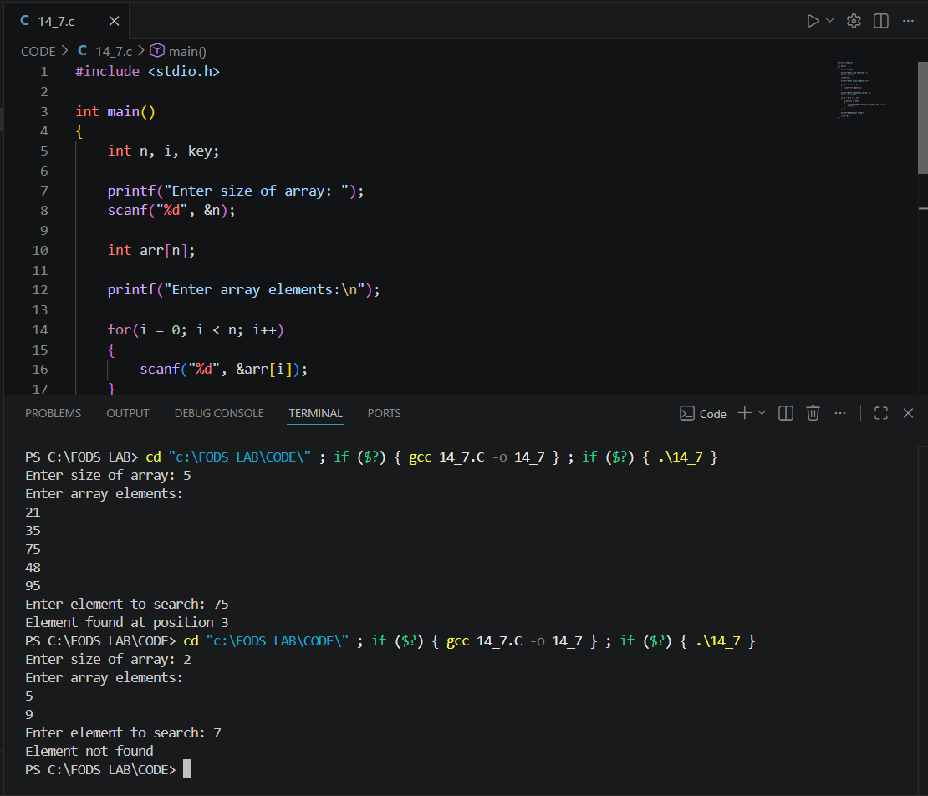

Time complexity And Space complexity:
CASE | NOTATION | COMPLEXITY
Best case | Ω | Ω(1)
Average case | θ | θ (n)
Worst case | O | O(n)

